[](https://www.google.co.uk/url?sa=i&rct=j&q=&esrc=s&source=images&cd=&cad=rja&uact=8&ved=0ahUKEwjIwPGjg4LOAhXiCcAKHXuiDfMQjRwIBw&url=https://www.colourbox.de/vektor/handshake-symbol-vektor-7409947&bvm=bv.127521224,d.ZGg&psig=AFQjCNFnACEQyf0GU27YMkTcZF0MYRkYNw&ust=1469103475871977)

**MI PRESENTO - I introduce myself**

1. **Write sentences about the following cartoon characters.**

**2a. Write the following numbers in digits.**

a. sedici ____ b. tredici ____ c. ventitré ____ d. trenta ____ e. due ____

f. diciotto _____ g. undici _____ h. sette _____ i. tre _____ j. uno ____

k. dieci _____ l. sei _____ m. quattro ____ n. nove ____ o. diciassette ____

**2. Write the number in Italian.**

a. example 12 *dodici*

|  |  |  |
| --- | --- | --- |
| **9** | **32** | **13** |
| **5** | **15** | **19** |
| **28** | **22** | **11** |
| **8** | **41** | **40** |
| **37** | **14** | **33** |

**3. Complete with the correct missing words.**

- Salve, _________ ti chiami?

# Mi _______ Paolo. E tu? come ti chiami?

- _____ chiamo Lorenzo. Quanti ____ hai, Paolo?

# ___ 13 anni. E tu? quanti anni hai?

- Ho quasi 12 ______.

**mi anni (x2) chiamo come ho**

**4a. Finish off the spelling of the following months and days of the week. Before doing this, revise their spelling. Do this task without looking at their spelling.**

|  |  |  |  |  |  |
| --- | --- | --- | --- | --- | --- |
| MA_ZO | OTTOB_E | MA_GIO | LU_LIO | FEBBRAI_ | NO_EMBRE |
| D_CEMBRE | GENNA_O | SE_TEMBRE | APR_LE | AGO_TO | GIUG_O |

|  |  |  |  |
| --- | --- | --- | --- |
| SA_ATO | ME_COLEDÌ | DOMENIC_ | _UN_DÌ |

|  |  |  |
| --- | --- | --- |
| GIO_EDÌ | MA_TED_ | VE_ERDÌ |

**4b. Now put months and days of the week in the correct order. Before doing this, revise their spelling. Do this task without looking at their spelling.**

|  |  |  |  |
| --- | --- | --- | --- |
| 1. | 2. | 3. | 4. |
| 5. | 6. | 7. | 8. |
| 9. | 10. | 11. | 12. |

|  |  |  |  |
| --- | --- | --- | --- |
| 1. | 2. | 3. | 4. |

|  |  |  |
| --- | --- | --- |
| 5. | 6. | 7. |

**5a. What's the date? *Che data è oggi?***

a. (example) Oggi è venerdì, otto marzo.

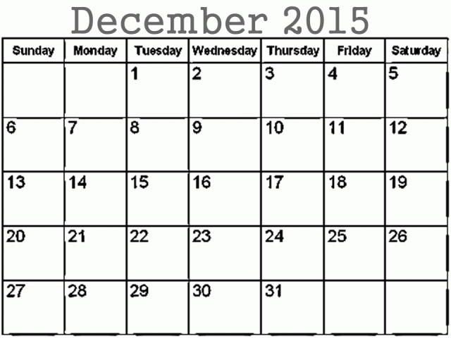 b. _______________ 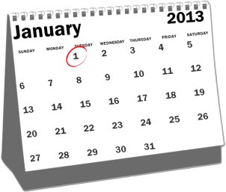c. _____________

_______________ _____________

 d. ______________  e. __________________

_______________ __________________

 f. _____________  g. ________________

______________ ________________

**Write today’s date.** Oggi__________________________________

**5b. Say when the following Italian festivities are. Help yourself with the suggested dates in the grid below.**

Che festa è? Which festivity is that?

|  |  |  |
| --- | --- | --- |
| a. | Oggi è il *venticinque* *dicembre* ed è *Natale* | http://images.clipartpanda.com/christmas-tree-clipart-christmas-tree27.png |
| b. | Oggi è il ______________ __________ ed è __________ | [http://www.wallstreetancona.it/wp-content/uploads/2012/12/happy-new-year-clipart.png](http://www.google.co.uk/url?sa=i&rct=j&q=&esrc=s&source=images&cd=&cad=rja&uact=8&ved=0ahUKEwjd0N-_7YHOAhULKMAKHbeED6UQjRwIBw&url=http://www.wallstreetancona.it/capodanno-2013-ancona&psig=AFQjCNH_d45YTYOPWiZnGgUNlafsF2mZgQ&ust=1469097678486926) |
| c. | Oggi è il ______________ __________ ed è __________ |  |
| d. | Oggi è il ______________ __________ ed è __________ | https://s-media-cache-ak0.pinimg.com/736x/fa/e7/92/fae792075eb83d858efad659894428a4.jpg |
| e. | Oggi è il ______________ __________ ed è __________ | [https://s-media-cache-ak0.pinimg.com/236x/c5/ea/b3/c5eab356fbdd205b2f4490e6a209d84e.jpg](https://www.google.co.uk/url?sa=i&rct=j&q=&esrc=s&source=images&cd=&cad=rja&uact=8&ved=0ahUKEwip_6a874HOAhWaOsAKHftACGQQjRwIBw&url=https://www.pinterest.com/Reace45/auction-2016-logo/&bvm=bv.127521224,d.ZGg&psig=AFQjCNHL_op641KdpPbzQdJXoAH_eBoXqg&ust=1469098175280058) |
| f. | Oggi è il ______________ __________ ed è __________ | http://lh4.ggpht.com/-TDGcIE8Z7K8/U5abzyl6hzI/AAAAAAAAN7k/DOuK4_C-S2U/fathersdayclips_thumb4.jpg?imgmax=800 |
| g. | Oggi è il ______________ __________ ed è __________ | [http://images.clipartpanda.com/easter-clipart-47f8cce8cfe3755800ca958aa711c17b.jpg](http://www.google.co.uk/url?sa=i&rct=j&q=&esrc=s&source=images&cd=&cad=rja&uact=8&ved=0ahUKEwiq9_Dl74HOAhXKAMAKHSDDC4QQjRwIBw&url=http://www.clipartpanda.com/categories/easter-clip-art-christian&bvm=bv.127521224,d.ZGg&psig=AFQjCNGdF58D_-XV8yygUMRH49RATRqI9w&ust=1469098279963076) |
| h. | Oggi è il ______________ __________ ed è __________ |  |
| i. | Oggi è il ______________ __________ ed è __________ | [http://www.rosalbacorallo.it/mamma.gif](http://www.google.co.uk/url?sa=i&rct=j&q=&esrc=s&source=images&cd=&cad=rja&uact=8&ved=0ahUKEwibl7e78IHOAhWEB8AKHdMWBswQjRwIBw&url=http://www.rosalbacorallo.it/mamma-immagini.html&bvm=bv.127521224,d.ZGg&psig=AFQjCNH3xO8gGFI5oD0JBhhRN4AZDSDXtw&ust=1469098467749567) |
| j. | Oggi è il ______________ __________ ed è __________ | [http://worldartsme.com/images/estate-clipart-1.jpg](http://www.google.co.uk/url?sa=i&rct=j&q=&esrc=s&source=images&cd=&cad=rja&uact=8&ved=0ahUKEwi6-ZXx8YHOAhVRGsAKHXUcDqYQjRwIBw&url=http://worldartsme.com/estate-clipart.html&bvm=bv.127521224,d.ZGg&psig=AFQjCNFXF8o3_KEIkFIA5PZMmkwuFc3A7w&ust=1469098775268663) |

|  |  |  |  |  |
| --- | --- | --- | --- | --- |
| 28/02 Carnevale | 16/04  Pasqua | 25/12  Natale | 15/08 Ferragosto | 14/02  San Valentino |
| 25/04  la festa della Liberazione | 01/01 Capodanno | 19/03  la festa del Papà | 06/01 l’Epifania | 14/05  la festa della Mamma |

**6a. When is your birthday**? Quando è il tuo compleanno?

**How old will you be?** Quanti anni compi?

 

14/07 24/04

Il mio compleanno è il 14 luglio _________________________

e *compio* 5 anni. _________________________

 

12/03 01/05

______________________ _________________________

______________________ _________________________

 

15/11 29/09

________________________ _______________________

________________________ _______________________

 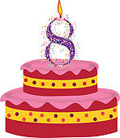

19/09 31/08

_______________________ ________________________

_______________________ ________________________

Come ti chiami? ____________________________________

Come si scrive? ____________________________________

Quando è il tuo compleanno? ____________________________________

Quanti anni compi? ____________________________________

**6b. Ask three classmates the following questions in Italian and jot down the answers in Italian. Wait for your classmate to give you the answer even if you may know it already! ☺**

**The person answering must use full sentences:**

**ex.** A. Come ti chiami? B. Mi chiamo *Maria***.**

|  |  |  |  |  |
| --- | --- | --- | --- | --- |
|  | Come ti chiami? | Come si scrive? | Quando è il tuo compleanno? | Quanti anni compi? |
| *Ex.* | *Maria* | *M-A-R-I-A* | *15/06* | *13* |
| 1. |  |  |  |  |
| 2. |  |  |  |  |
| 3. |  |  |  |  |

**6c.Now, pretend to be the people that have been interviewed and write a small paragraph for each of them. Write numbers in words.**

*Ex. Ciao, mi chiamo Maria. Si scrive M-A-R-I-A. Il mio compleanno è il quindici giugno e compio tredici anni.*

1. Salve! Mi chiamo ___________. Si scrive ____________. Il mio compleanno è il _______________ _____________ e compio ______________ anni.
2. Buongiorno! Mi ch_______ ____________ . Si scr____ __________. Il mio comp__________ è il ______________ _____________ e comp___ _________ anni.
3. Ciao! ___________________________________________________

_______________________________________________________

**6d. NOW IT IS YOUR TURN!**

**TOCCA A TE!**

**Write a small paragraph about yourself (***Come ti chiami?/Come si scrive?/Quando è il tuo compleanno?/Quanti anni compi?***).**

**Try and do this without looking at the previous examples! How well do you remember the spelling of the expressions you need to use?**

Ciao! ____________________________________.

________________________________________.

________________________________________.

________________________________________.

**WHERE AM I?**

**How well do you know the Italian expressions for:**

*My name is/it is spelt/My birthday is/I will be…years old ?*

**Very well __ Pretty well __ So and so __ I still have to get there __**

**ACTION!** [](http://www.google.co.uk/url?sa=i&rct=j&q=&esrc=s&source=images&cd=&cad=rja&uact=8&ved=0ahUKEwiLrqqHgILOAhUFLMAKHSBuB64QjRwIBw&url=http://www.gograph.com/vector-clip-art/muscle-arms.html&bvm=bv.127521224,d.ZGg&psig=AFQjCNFSp8egMtIsTJBSs5QZswZNy7KWHw&ust=1469102645833848)

Copy down the Italian equivalents of the following English expressions 4 times each. Refer to the vocabulary list at the back of the booklet for correct spelling.

|  |  |  |  |
| --- | --- | --- | --- |
| My name is |  | | |
| 1 | 2 | 3 | 4 |
|  | | | |
| It is spelt |  | | |
| 1 | 2 | 3 | 4 |
|  | | | |
| My birthday is |  | | |
| 1 | 2 | 3 | 4 |
|  | | | |
| I will be 12 years old |  | | |
| 1 | 2 | 3 | 4 |



**L’ ITALIA: regioni e città**

1. **GO ONLINE AND LOOK FOR A MODERN POLITICAL AND PHYSICAL MAP OF ITALY TO BE ABLE TO FIND THE FOLLOWING INFORMATION:**

1a. Label each Italian region with its name and main city. Colour in each region with a different colour. Use crayons only!

1b. Label the seas surrounding the Italian peninsula.

1c. Draw in blue and then label the *Arno River*, *Tevere River*. Make sure that you draw them in the correct region!

1d. Draw in blue and then label *Como Lake* and *Garda Lake*. Make sure that you draw them in the correct region!

1e. Draw in brown and then label the following Italian mountain ranges: *Le Alpi* (the Alps) and *gli Appennini* (the Appenines)

1f. Draw in grey the two main Italian volcanoes *Vesuvio* and *Etna*.

1g. Label the neighbouring countries.

**In order to avoid smudges, make sure that regions and the natural landmarks are coloured in with CRAYONS ONLY! ☺**

|  |  |  |  |  |
| --- | --- | --- | --- | --- |
| Lazio  Roma | Puglia  Bari | Sicilia  Palermo | Calabria  Catanzaro | Basilicata  Potenza |
| Campania  Napoli | Molise  Campobasso | Abruzzo  Aquila | Umbria  Perugia | Emila-Romagna  Bologna |
| Toscana  Firenze | Marche  Ancona | Lombardia  Milano | Valle D’Aosta  Aosta | Veneto  Venezia |
| Liguria  Genova | Piemonte  Torino | Friuli-Venezia-Giulia  Udine | Trentino Alto Adige  Trento | Sardegna  Cagliari |

**LA MAPPA ITALIANA**

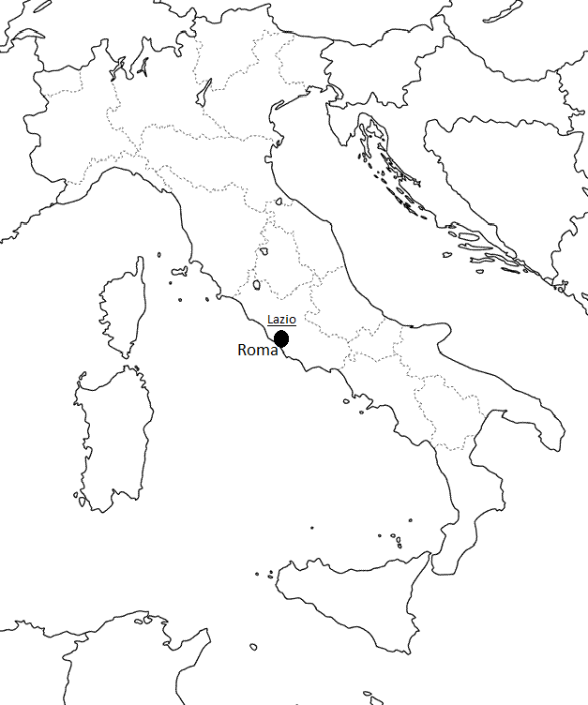

**2. GO ON LINE AND CHECK IN WHICH REGION AND CITY THE**

**FOLLOWING LANDMARKS ARE SITUATED.**

LA MAPPA DELLE BELLEZZE ARTISTICHE E NATURALI DELL’ ITALIA.

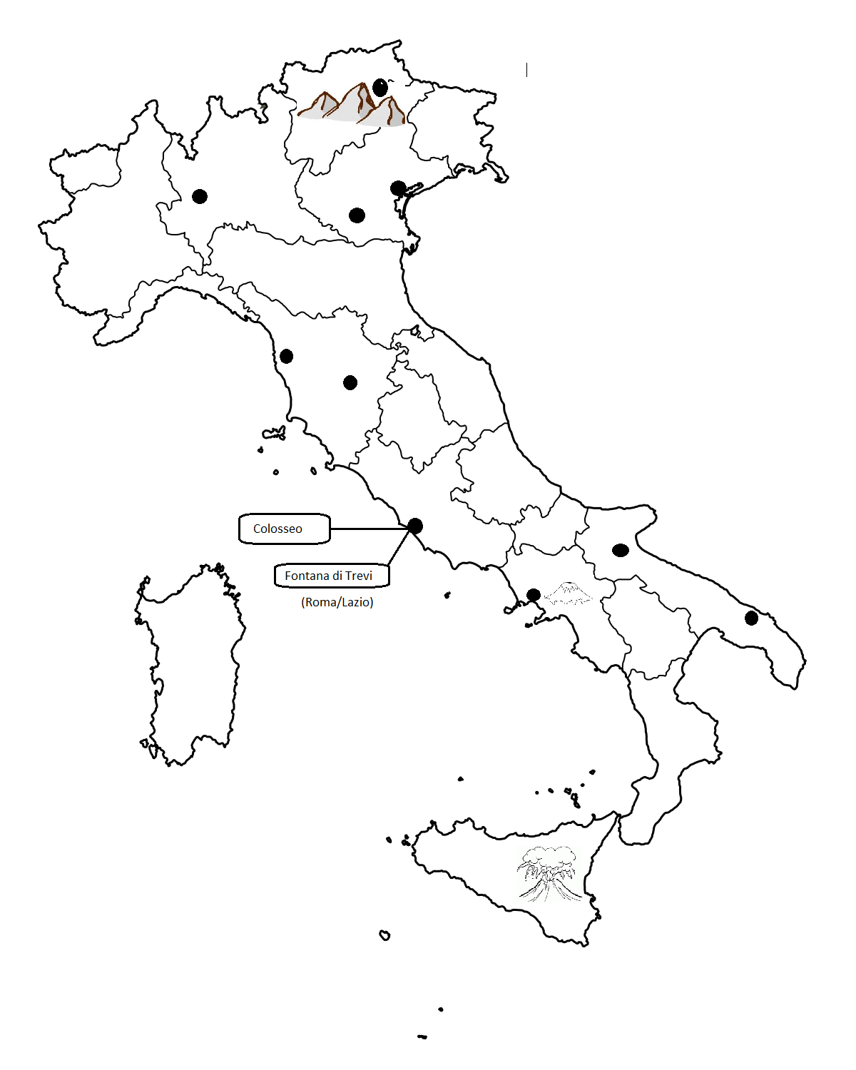

**3. Write sentences in the io-form giving the information needed.**

**DOVE ABITI? Where do you live?**

|  |  |  |
| --- | --- | --- |
| A. | Nome: Diana  Età:13 anni  Indirizzo: via **Alessandro Volta** n. 16, Roma  Nata a: Napoli | (Example)  Ciao! Mi chiamo Diana ed ho 13 anni.  Abito a Roma in via A. Volta n. 16 **ma** vengo da Napoli. |
| B.  https://thetomatos.com/wp-content/uploads/2016/05/teenagers-clipart.png | Nome: Federica  Età: *quasi* 15 anni  Indirizzo: via **Marconi** n. 23, Bari  Nata a: Taranto | ________________________________  ________________________________  ________________________________  ________________________________  ________________________________  ________________________________ |
| C.  https://pixabay.com/static/uploads/photo/2016/04/01/10/52/blonde-1300066_960_720.png | Nome: Simone  Età: 11 anni  Indirizzo: via **Francesco Petrarca** n. 4, Palermo  Nato a: Catania | ________________________________  ________________________________  ________________________________  ________________________________  ________________________________ |
| D. | Nome: Giorgio  Età: 12 anni  Indirizzo: via **Luigi Pirandello** n. 14, Bologna  Nato a: Pisa | ________________________________  ________________________________  ________________________________  ________________________________  ________________________________  ________________________________ |
| E.  http://images.clipartlogo.com/files/images/11/116951/comic-girl_t | Nome: Nicoletta  Età: 16 anni  Indirizzo: via **Galileo Galilei** n. 29, Pisa  Nata a: Arezzo | ________________________________  ________________________________  ________________________________  ________________________________  ________________________________  ________________________________ |
| F. | Nome: Andrea  Età: 17 anni  Indirizzo: via **Giotto** n. 56, Torino  Nato a: Asti | ________________________________  ________________________________  ________________________________  ________________________________  ________________________________  ________________________________ |
| G.  http://www.deluxevectors.com/images/vector_images/thumb/people-faces-kid-clip-art.jpg  **Did you know that** Italian streets are named after famous historical people (poets, artists, inventors, politicians) and after towns or countries?  **4. Use the Internet to find out who the people, after whom the above streets are named, were. Write your findings in your writing book.** | Nome: Egidio  Età: 27 anni  Indirizzo: via **Marco Polo** n. 39, Padova  Nato a: Ferrara | ________________________________  ________________________________  ________________________________  ________________________________  ________________________________  ________________________________ |

**5. Read the paragraphs and say who is who?**

Salve, il mio nome è _______. Abito a Napoli con la mia famiglia ed ho sedici anni. Il mio compleanno è a luglio.

Ciao, mi chiamo _________. Il mio compleanno è a luglio. Ho ventitré anni ed abito in Toscana.

Buongiorno, il mio nome è _______. Il mio compleanno è a dicembre ed ho diciannove anni. Vivo in Puglia con mia madre.

**Extension**

1. Another way to say *I live* ________
2. Another way to say *my name is* ______
3. Write a paragraph about yourself now.

Do this in your writing book.

Salve, mi chiamo _______. Vivo a Milano con mio padre e mia madre. Ho quindici anni ed il mio compleanno è a luglio.

Ciao! Mi chiamo ___________. Ho ventitré anni ed il mio compleanno è il dodici marzo. Abito a Torino.

**6. Translate into Italian the following sentences.**

a. Hi! My name is Francesco and I am 13 years old. ___________________________________________________________

b. I will be 14 on the 20th of September.

___________________________________________________________

c. I live in Naples with my family but I come from Bari.

___________________________________________________________

**WHERE AM I?**

**How well do you know the Italian expressions for:**

*I live in Hoddesdon/I live in ____ road/I come from/*

**Very well __ Pretty well __ So and so __ I still have to get there __**

**ACTION!** [](http://www.google.co.uk/url?sa=i&rct=j&q=&esrc=s&source=images&cd=&cad=rja&uact=8&ved=0ahUKEwiLrqqHgILOAhUFLMAKHSBuB64QjRwIBw&url=http://www.gograph.com/vector-clip-art/muscle-arms.html&bvm=bv.127521224,d.ZGg&psig=AFQjCNFSp8egMtIsTJBSs5QZswZNy7KWHw&ust=1469102645833848)

Copy down the Italian equivalents of the following English expressions 4 times each. Refer to the vocabulary list at the back of the booklet for correct spelling.

|  |  |  |  |
| --- | --- | --- | --- |
| I live in Hoddesdon. |  | | |
| 1 | 2 | 3 | 4 |
|  | | | |
| I live in ... road. |  | | |
| 1 | 2 | 3 | 4 |
|  | | | |
| I come from... |  | | |
| 1 | 2 | 3 | 4 |

**LA MIA FAMIGLIA- My family**

**7a. Complete with the correct indefinite article (un/uno/una/un’) and then write the plural of these words.**

|  |  |
| --- | --- |
| 1. *un* figlio | *due*  figli |
| 1. ____ figlia | ____ figli_ |
| 1. ____ zia | ____ zi_ |
| 1. ____ zio | ____ zi_ |
| 1. _____ nonna | ____ nonn_ |
| 1. _____nonno | ____ nonn_ |
| 1. _____ marito | ____ marit_ |
| 1. _____ moglie | ____ mogli_ (f) |
| 1. _____ sorella | ____ sorell_ |
| 1. _____ patrigno | ____ patrign_ |
| 1. _____ matrigna | ____ matrign_ |
| 1. _____ padre | ____ padr_ (m) |
| 1. _____ madre | ____ madr_ (f) |
| 1. _____ fratello | ____ fratell_ |
| 1. _____ scoiattolo | ____ scoiattol_ |
| 1. _____ cane | ____ can_ (m) |
| 1. _____ anatra | ____ anatr_ |
| 1. _____ criceto | ____ cricet_ |
| 1. _____ serpente | ____ serpent_ (m) |
| 1. _____ uccello | ____ uccell_ |

**7b. Pretend to be Lisa and write sentences about your family.**

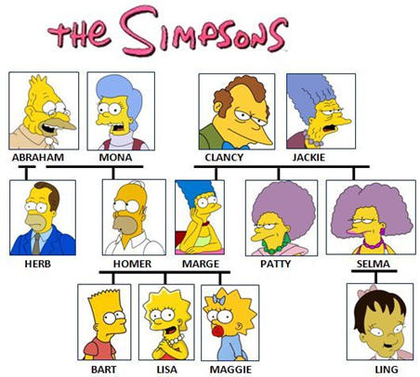

Ciao! Mi chiamo Lisa ed ho 8 anni.

1. Ho *un fratello*. ***Lui*** si chiama Bart ed *ha* *10* anni. (example)
2. Ho anche una _________ . ***Lei*** si chiama *Maggie* ed ha *1* anno.
3. Ho una madre. _____ si chiama Marge ed ____ 40 anni.
4. ____ un padre. Lui _________ Homer ed ha 42 _____.
5. Ho ___ zio. Lui si _________ Herb ed ha 38 anni.
6. Ho ____ cugina. Lei ___ chiama ______ ed ha *solo* 5 anni.
7. Ho ____ zie. Loro ___ chiamano Patty e Selma ed hanno 36 anni.

**7c. Rewrite the above sentences by using *che* (who/that).**

1. (esempio) Ho un fratello **che** *si chiama* Bart ed *ha* 10 anni.
2. ____________________________________________
3. ____________________________________________
4. ____________________________________________
5. ____________________________________________
6. ____________________________________________
7. Ho due zie **che** *si chiamano* Patty e Selma ed *hanno* 36 anni.

**E tu, hai un fratello o una sorella?**

___________________________________________________

___________________________________________________

**8. Match the pictures with the correct family relationship.**

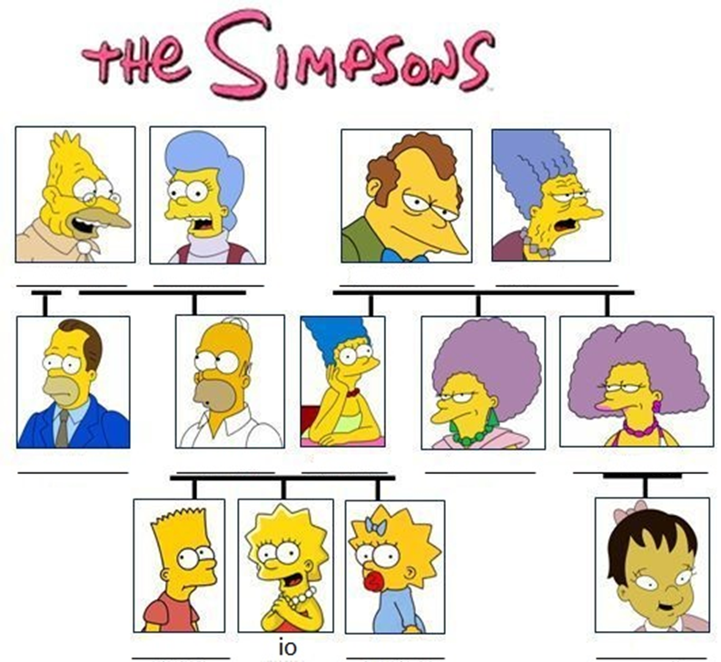

|  |  |  |  |  |  |
| --- | --- | --- | --- | --- | --- |
| mia cugina | mio fratello | mia sorella | mio zio | mia zia (x2) | mio padre |
| mio nonno (x2) | mia nonna (x2) | mia madre |  | | |

**WHERE AM I?**

**How well do you know the Italian expressions for:**

*I have a brother/sister/he/she is called/he/she is...years old/*

*I have two sisters/They are called/they are...years old.*

**Very well __ Pretty well __ So and so __ I still have to get there __**

**ACTION!** [](http://www.google.co.uk/url?sa=i&rct=j&q=&esrc=s&source=images&cd=&cad=rja&uact=8&ved=0ahUKEwiLrqqHgILOAhUFLMAKHSBuB64QjRwIBw&url=http://www.gograph.com/vector-clip-art/muscle-arms.html&bvm=bv.127521224,d.ZGg&psig=AFQjCNFSp8egMtIsTJBSs5QZswZNy7KWHw&ust=1469102645833848)

Copy down the Italian equivalents of the following English expressions 4 times each. Refer to the vocabulary list at the back of the booklet for correct spelling.

|  |  |  |  |
| --- | --- | --- | --- |
| I have a sister |  | | |
| 1 | 2 | 3 | 4 |
|  | | | |
| She is called |  | | |
| 1 | 2 | 3 | 4 |
|  | | | |
| She is...years old |  | | |
| 1 | 2 | 3 | 4 |

**9. Translate the following sentences into Italian.** a. I have a brother. ____________________________________________

b. He is called Bart. ____________________________________________

c. He is 10 years old. ___________________________________________

d. I have a brother who is called Bart and who is 10 years old. ___________________________________________________________

e. I have two aunties who are called Patty and Selma and who are 44 years old. __________________________________________________________

f. I have a father. My father is called Homer and he is 43 years old.

**9. Write sentences on each of the characters below. Use intensifiers (*molto*-very/*abbastanza*-quite/*piuttosto*-rather/*un po’*- a bit/*-issimo* (-a)).**

a. Lei è *molto* alta. (ex.)

b. Lui è molto ____________.

c. Lui ___ di altezza ________.

d. ___ è magr-________.

e. ____ __ abbastanza _____________.

f. Mario è ______________.

g. Carmen ___ _____________.

h. _______ è ______________.

i. Il signor Rossi ha il viso _____________.

j. La signora Bianco ___ il _______ ovale.

k. La signorina Carmen ____ la __________ scura.

l. Giovanna ha la ___________ __________ .

m. Mio zio ha il viso ____________.

n. Antonio ha i __________

a _______________.

o. Carletto ____ i capelli ___________ e corti.

p. Monica __i capelli biondi ed ____________.

q. Miriana ha i _________corti e __________.

Example: A. Lei è *molto* alta.

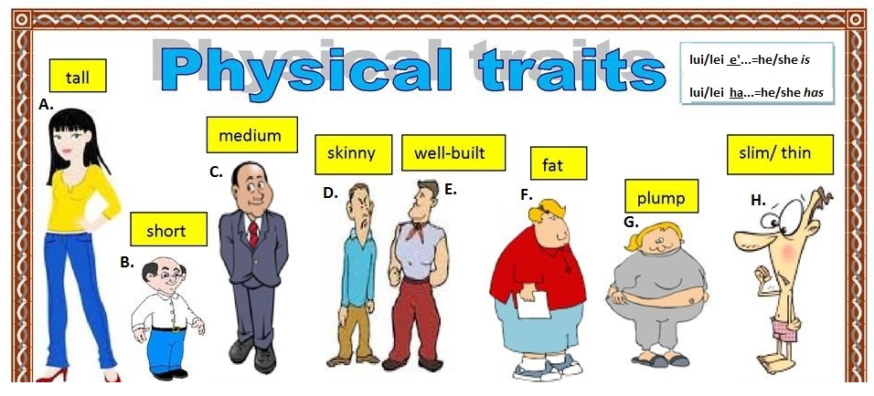 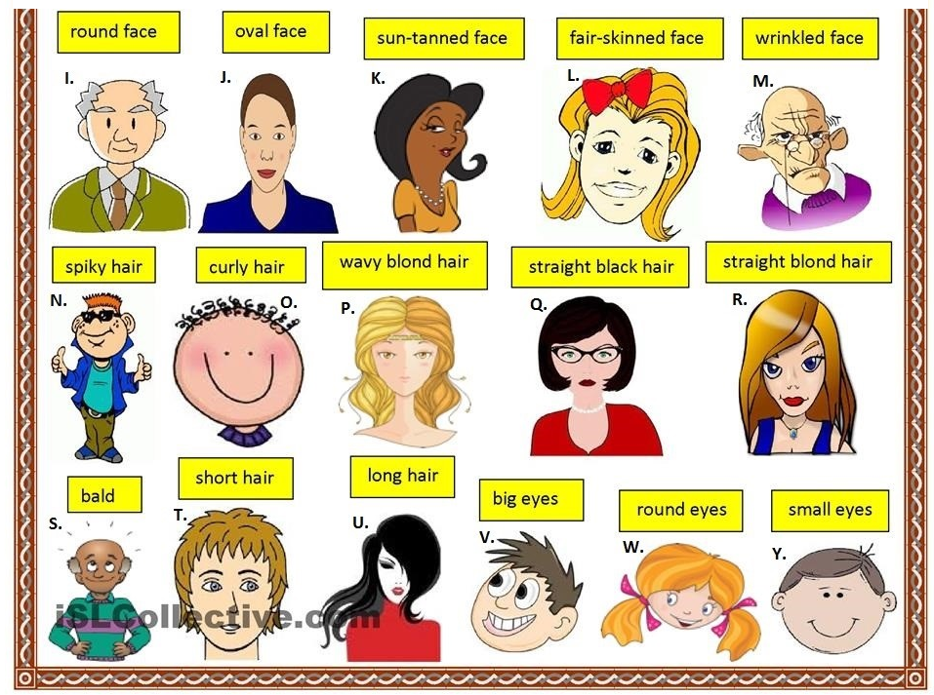

r. Mia sorella ha i ____________ biondi e ________________.

s. Gino _____ calvo.

t. Terenzio ____ __ capelli corti.

u. Milena ___ __ _______________ ____________ ________________.

v. Cristiano ha gli _____________ _________________.

w. Susanna ha ____ _____________ _______________.

x. Mio cugino ____ ____ _______________ ______________.

dark-skinned

fair-skinned

**10a. *As you already know*, some personality adjectives end in -*o* (*simpatico*) and some end in -*e* (*paziente*) in the masculine. Now, here is a list of adjectives with an unfinished spelling that need completing with -*o* or -*e*. Basically, tell us if the following adjectives belong to the group ending in -*o* or to the group ending in -*e.***

|  |  |
| --- | --- |
| Studios*o* (example) | Seri__ |
| Pigr__ | Pazient__ |
| Intelligent__ | Sciocc__ |
| Ordinat__ | Noios__ |
| Gentil__ | Sportiv__ |
| Prepotent__ | Divertent*e* (example) |
| Generos__ | Timid__ |
| Disordinat__ | Simpatic__ |
| Allegr__ | Antipatic__ |

**Extension activity: By using a dictionary, find the Italian equivalent for the following English adjectives. Does their singular masculine form end in -o or in -e?**

|  |
| --- |
| stubborn |
| proud |
| humble |
| sad |
| happy |

**10b. Now, turn the adjectives above into feminine.**

**Remember**: 1. simpatico (m.) simpatica (f.) **(-o -a)**

2.paziente (m.) paziente (f.) **(-e -e)**

|  |  |
| --- | --- |
| Studiosa (ex.) | Seri__ |
| Pigr__ | Paziente (ex.) |
| Intelligent__ | Sciocc__ |
| Ordinat__ | Noios__ |
| Gentil__ | Sportiv__ |
| Prepotent__ | Divertent__ |
| Generos__ | Timid__ |
| Disordinat__ | Simpatic__ |
| Felic__ | Orgoglios__ |
| Allegr__ | Antipatic__ |

**11. From memory, finish off the spelling of the following personality adjectives in the masculine form.**

|  |  |
| --- | --- |
| Sim__atic*o* | Di__or__in__to |
| Sc__oc__o | Pi__r__ |
| __im__do | Chia__ c__ie__ron__ |
| Div__rt__ __te | In__el__igen__e |
| S__o__tivo | Gen__il__ |
| Pre__ote__te | O__di__at__ |
| Ge__ero__o | Stud__o__ __ |
| Ca__ tiv__ | Se__er__ |
| Dil__ __ent__ | N__i__so |

**12. Write the feminine or masculine of the following adjectives.**

|  |  |
| --- | --- |
| **(Io) sono... http://tbn0.google.com/images?q=tbn:xJXBWs3-h1VOZM:http://www.simpsoncrazy.com/gallery/images/BartSimpson8.gif** | **(Io) sono... http://tbn0.google.com/images?q=tbn:EQFGVNyw-zFx1M:http://simpsonspedia.net/images/thumb/e/ec/Lisa_Simpson.png/500px-Lisa_Simpson.png** |
| simpatico | simpatic*a* (example) |
|  | coraggiosa |
| divertente |  |
|  | intelligente |
| serio |  |
| paziente |  |
|  | generosa |
| aggressivo |  |
| sportivo |  |
|  | diligente |

**13. Write the opposite personality adjective. Help yourself with the vocabulary list provided at the end of this booklet.**

|  |  |
| --- | --- |
| ***divertente*** | ***noioso (example)*** |
|  | triste |
| buono |  |
| simpatico |  |
|  | disordinato |
|  | prepotente |
| sportivo |  |
| silenzioso |  |
|  | stupido |
| allegro |  |
|  | impaziente |
| socievole |  |
|  | triste |

**14a. Read the paragraphs and match them with the correct person.**

|  |  |
| --- | --- |
| a. Ciao! Mi chiamo Cristina. Ho dodici anni. Sono alta e abbastanza grassa. Sono simpatica e molto bella. Sono castana ed ho i capelli lunghi e ricci. |  |
| b. Il mio nome è Sandra. Ho quattordici anni. Ho i capelli lunghi e ricci e sono bionda e molto alta. |
| **c.** Mi chiamo Sofia ed ho tredici anni. Ho i capelli lunghi e lisci e sono bionda. Sono bassa e magra. Sono divertente e un po’ timida. |
| **d.** Sono Gianni ed a novembre compio quindici anni. Sono alto e magro. Sono biondo ed ho i capelli corti e lisci. Sono molto superstizioso. |
| **e.** Mi chiamo Lorenzo e *festeggio* il mio compleanno a dicembre. Ho i capelli corti, rossi e lisci. Sono abbastanza alto e magro. Sono sportivo *e anche* studioso. |
| **f.** Salve! Sono Nicola. Ho dodici anni. Ho i capelli corti, ricci e sono castano. Sono abbastanza basso e abbastanza grasso. Sono molto sportivo e simpatic*issimo*. |

**WHERE AM I?**

**How well do you know the Italian expressions for:**

*I have...hair/I have...eyes/I am (height)*

*He/she ...hair/He/she...eyes/He/she is height)*

*I am (personality)*

**Very well __ Pretty well __ So and so __ I still have to get there __**

**ACTION!** [](http://www.google.co.uk/url?sa=i&rct=j&q=&esrc=s&source=images&cd=&cad=rja&uact=8&ved=0ahUKEwiLrqqHgILOAhUFLMAKHSBuB64QjRwIBw&url=http://www.gograph.com/vector-clip-art/muscle-arms.html&bvm=bv.127521224,d.ZGg&psig=AFQjCNFSp8egMtIsTJBSs5QZswZNy7KWHw&ust=1469102645833848)

Copy down the Italian equivalents of the following English expressions 4 times each. Refer to the vocabulary list at the back of the booklet for correct spelling.

|  |  |  |  |
| --- | --- | --- | --- |
| I have... |  | | |
| 1 | 2 | 3 | 4 |
|  | | | |
| I am... |  | | |
| 1 | 2 | 3 | 4 |
|  | | | |
| She/he has... |  | | |
| 1 | 2 | 3 | 4 |
| She/he is... |  | | |
| 1 | 2 | 3 | 4 |

**14b. Translate the following sentences into Italian. Pay attention to the position of adjectives. Remember that they go after the object they describe.**

a. I have long hair. _____________________________________________

b. I have long and blond hair. ______________________________________

c. I have long, blond, straight hair. _______________________________

d. I have green eyes. ____________________________________________

d. I am *very* tall and *a bit* fat. (m.) __________________________________

e. I am *quite* small and thin. (f.) ____________________________________

f. I am *very* sporty. (f.) __________________________________________

g. I am organised and also *very* studious. (f.)__________________________

___________________________________________________________

**(extra)**

h. My name is Giorgio. ___________________________________________

i. I am 14 years old. ____________________________________________

j. I will be 15 in April. ___________________________________________

k. My birthday is on the 15th April. ________________________________

l. I live in Milan with my mother. __________________________________

m. I come from Venice. __________________________________________

**15a. Read the following descriptions of the Simpsons' family and say who is who.**

Salve, io mi chiamo ____________. Sono simpatico e ***anche***molto *goloso*. ***Mi piace*** molto la pizza, la birra e lo sport. ***Sfortunatamente***, sono anche *molto* disordinato e *poco* paziente.

Ciao, il mio nome è __________. ***Mi piace*** molto la scuola e ***quindi*** sono diligente ed intelligente. ***In genere*** sono paziente ***ma non***con mio fratello Bart **che** è molto scocciante ed aggressivo.

[](http://www.google.co.uk/url?sa=i&rct=j&q=&esrc=s&source=images&cd=&cad=rja&uact=8&ved=0ahUKEwiy7vDTovbOAhWKOxQKHbDkBfAQjRwIBw&url=http://www.clipartpanda.com/categories/pencil-clipart-black-and-white&bvm=bv.131783435,d.ZGg&psig=AFQjCNHYsewaG8ZYiHiANEoxNlRe23-AqQ&ust=1473097682652022)

[](http://www.google.co.uk/url?sa=i&rct=j&q=&esrc=s&source=images&cd=&cad=rja&uact=8&ved=0ahUKEwiy7vDTovbOAhWKOxQKHbDkBfAQjRwIBw&url=http://www.clipartpanda.com/categories/pencil-clipart-black-and-white&bvm=bv.131783435,d.ZGg&psig=AFQjCNHYsewaG8ZYiHiANEoxNlRe23-AqQ&ust=1473097682652022)

Buongiorno, io sono ________. ***Penso di essere***sportivo e molto socievole. ***Infatti*,** ***amo*** lo skateboard e il football americano. ***Non mi piace*** la scuola **perchè** ***penso che sia***noiosa.

Buongiorno, io sono ________e sono la _________ di Lisa, Bart e Maggie. ***Penso di essere*** molto paziente con Bart e mio *marito* Homer.

[](http://www.google.co.uk/url?sa=i&rct=j&q=&esrc=s&source=images&cd=&cad=rja&uact=8&ved=0ahUKEwiy7vDTovbOAhWKOxQKHbDkBfAQjRwIBw&url=http://www.clipartpanda.com/categories/pencil-clipart-black-and-white&bvm=bv.131783435,d.ZGg&psig=AFQjCNHYsewaG8ZYiHiANEoxNlRe23-AqQ&ust=1473097682652022)

|  |  |  |
| --- | --- | --- |
| [Bart Simpson PNG Clipart](http://www.pngall.com/wp-content/uploads/2016/06/Bart-Simpson-PNG-Clipart.png)**Bart** | [Image result for lisa simpson](http://www.google.co.uk/url?sa=i&rct=j&q=&esrc=s&source=images&cd=&cad=rja&uact=8&ved=0ahUKEwj_8YKDoPbOAhVEPxQKHa27BwEQjRwIBw&url=http://www.simpsoncrazy.com/pictures/lisa&bvm=bv.131783435,d.ZGg&psig=AFQjCNHxzhrLaiiaK-G5qrV0C5F15jYblg&ust=1473096975565877) **Lisa** | [Image result for marge simpson](http://www.google.co.uk/url?sa=i&rct=j&q=&esrc=s&source=images&cd=&cad=rja&uact=8&ved=0ahUKEwjI85yloPbOAhUD6RQKHe0JA2gQjRwIBw&url=http://www.simpsoncrazy.com/pictures/marge&bvm=bv.131783435,d.ZGg&psig=AFQjCNEGA93SMtinBBKOvmjm-fcU21afmw&ust=1473097029228445)**Marge** |
| [Image result for homer simpson](http://www.google.co.uk/url?sa=i&rct=j&q=&esrc=s&source=images&cd=&cad=rja&uact=8&ved=0ahUKEwiyvaSanvbOAhUBERQKHeQ4CWQQjRwIBw&url=http://www.latimes.com/entertainment/arts/culture/la-et-cm-dan-castellaneta-homer-simpson-to-sta-001-photo.html&bvm=bv.131783435,d.ZGg&psig=AFQjCNE35ap4a5Z82z7a1kK_djek4KQ2BA&ust=1473096469056266)**Homer** | [Image result for maggie simpson face](http://www.google.co.uk/url?sa=i&rct=j&q=&esrc=s&source=images&cd=&cad=rja&uact=8&ved=0ahUKEwjKxa3coPbOAhWJbxQKHfXeC7gQjRwIBw&url=http://www.keyword-suggestions.com/bWFnZ2llIHNpbXBzb24gZmFjZQ/&bvm=bv.131783435,d.ZGg&psig=AFQjCNEbqAN7lCKQXSfAdiRd1oPENwmXIw&ust=1473097161354151)**Maggie** | |

[](http://www.google.co.uk/url?sa=i&rct=j&q=&esrc=s&source=images&cd=&cad=rja&uact=8&ved=0ahUKEwiy7vDTovbOAhWKOxQKHbDkBfAQjRwIBw&url=http://www.clipartpanda.com/categories/pencil-clipart-black-and-white&bvm=bv.131783435,d.ZGg&psig=AFQjCNHYsewaG8ZYiHiANEoxNlRe23-AqQ&ust=1473097682652022)

**15b. Find the Italian equivalent of the following connectives:**

and- ______ but- ______ therefore- ________ also- ________

because- _______________ unfortunately- ________________

in generale- ____________ but not- ____________

as a matter of fact- _______________

**15c. Find the Italian equivalent of the following opinion verbs and expressions.**

I like- _____________ I do not like- _____________________

I love- _____________ I think I am- ______________________

I think it is- ________________

**16. Rewrite the following sentences in the negative form (non).**

|  |  |
| --- | --- |
| 1. Io sono paziente. | (ex.) Io *non* sono paziente. |
| 2. (io) sono sportiva. | (io) _____ sono sportiva. |
| 3 (io) sono generoso. | (io) non ______ generoso. |
| 4 (io) sono divertente. | (io) ______ ________ divertente. |
| 5. Luca è gentile. | Luca _____ è gentile. |
| 6. Martina è simpatica. | Martina non _____ simpatica. |
|  |  |
| 7. Filippo è noioso. | Filippo... |
| 8. Nicola è attivo. | Nicola... |
| 9. Andrea è goloso. | Andrea... |
| 10. Carla è disordinata. | Carla... |

**17a. Correct the false descriptions given below by using the negative form of the verb (*non*) and the connective *ma* (but).**

|  |  |
| --- | --- |
| **Homer è paziente.** | **Marge è antipatica.** |
| Homer ***non è*** paziente **ma** impaziente! (ex.)  http://tbn0.google.com/images?q=tbn:rOnricuycdr8CM:http://www.simpsonstrivia.com.ar/simpsons-photos/wallpapers/homer-strangles-bart.gif | http://tbn0.google.com/images?q=tbn:wBsvhF3WKACbSM:http://msnbcmedia4.msn.com/j/msnbc/Components/Photos/z_Projects_in_progress/_Ent/Simpson_Universe/simpsons_marge.widec.jpg |
| **Homer è sportivo.** | **Maggie è chiacchierona.** |
| **http://tbn0.google.com/images?q=tbn:bi69FUc922hObM:http://studio2628.files.wordpress.com/2008/04/homer-simpson-21.jpg** | http://vignette2.wikia.nocookie.net/simpsons/images/5/51/Maggiesimpson.png/revision/latest/scale-to-width-down/260?cb=20140110020232 |
| **Lisa è stupida.** | **Il signor Burns è buono.** |
| **http://tbn0.google.com/images?q=tbn:unj6m6g0-vUTIM:http://www.dollymix.tv/lisasimpson.jpg** | https://s-media-cache-ak0.pinimg.com/236x/da/09/e8/da09e8940b3d2f7ccfa78b349a67ff8d.jpg |

**17b. Rewrite the sentences below by using *Penso di essere (I think I am)* or *Penso che sia (I think it/she/he is).***

a. Lisa **è** molto intelligente --- ***Penso che*** *Lisa* ***sia*** *molto intelligente. (example)*

b. Bart **è** molto scocciante --- _____________________________________

c. **Io sono** abbastanza sportiva.--- __________________________________

d. Ludovico **è** simpaticissimo!--- ____________________________________

e. **Io sono** molto diligente. --- _____________________________________

f. Marta **è** proprio antipatica! --- ___________________________________

g. Paola *non* **è** ordinata. --- ________________________________________

h. Pasquale *non* **è** pigro. --- ________________________________________

i. **Io sono** un po' pigra. --- ________________________________________

**18. Pretend to be Lisa and write a paragraph for each member of your family. Try also to use *Penso che sia* (I think it/she/he is) when giving an opinion.**

|  |  |
| --- | --- |
| [Bart Simpson PNG Clipart](http://www.pngall.com/wp-content/uploads/2016/06/Bart-Simpson-PNG-Clipart.png) http://t1.gstatic.com/images?q=tbn:tVZRr19kCb2zIM:http://www.clker.com/cliparts/3/d/9/1/11949847661568287344heart_jon_phillips_01.svg.hi.png | [Image result for marge simpson](http://www.google.co.uk/url?sa=i&rct=j&q=&esrc=s&source=images&cd=&cad=rja&uact=8&ved=0ahUKEwjI85yloPbOAhUD6RQKHe0JA2gQjRwIBw&url=http://www.simpsoncrazy.com/pictures/marge&bvm=bv.131783435,d.ZGg&psig=AFQjCNEGA93SMtinBBKOvmjm-fcU21afmw&ust=1473097029228445) |
| _____________________________  _____________________________  _____________________________  _____________________________  _____________________________  _____________________________  _____________________________ | **Ho** una _________ **che si chiama** _________ **ed ha** 43 _____.  ____________ mia madre  **perché è** molto ______________ e ______________ con me.  *gentile anni Marge paziente*  *madre amo* |
|  | |
| http://t1.gstatic.com/images?q=tbn:4wBN3dTeWa8irM:http://www.myspaceanimations.com/images/hearts-3d-graphic.gif | http://t1.gstatic.com/images?q=tbn:tVZRr19kCb2zIM:http://www.clker.com/cliparts/3/d/9/1/11949847661568287344heart_jon_phillips_01.svg.hi.png |
| _____________________________  _____________________________  _____________________________  _____________________________  _____________________________  _____________________________  _____________________________ | _____________________________  _____________________________  _____________________________  _____________________________  _____________________________  _____________________________  _____________________________ |

**19a. Match the two columns to form complete sentences.**

|  |  |
| --- | --- |
| Ciao! Mi chiamo... | *12 anni.* |
| Ho... | *a Torino.* |
| Il mio compleanno è... | *Daniela.* |
| Abito... | *da Roma.* |
| Ma vengo... | *il 15 settembre.* |

|  |  |
| --- | --- |
| Sono... | *diligente.* |
| Ho... | *di altezza media e magra.* |
| Penso di essere... | *i capelli corti e ricci castani.* |

|  |  |
| --- | --- |
| Ho una sorella... | *mia sorella...* |
| Lei ha... | *è simpaticissima...* |
| Mi piace... | *un po' pigra.* |
| perché... | *17 anni.* |
| ma anche... | *che si chiama Paola.* |

**19b. By using the expressions in the first column as sentence starters, now write a paragraph about yourself. Try and use some of the expressions (connectives and opinion verbs) you came across in activity 15.**

Ciao! Mi chiamo _______________________________________________ ____________________________________________________________________________________________________________________________________________________________________________________________________________________________________________________________________________________________________________________________________________________________________________________________________________________________________________________________________________________________________________________________________________________________________________________________________________________________________________________________________________________________________________________________________________________________________________________________________________________________________________________________________________________________________________________________________________________________________________________________________________________________________________________________________________________________________________________________________________________________________________________________________________________________

**WHERE AM I?**

**How well do you know the Italian expressions for:**

*He/she is (personality) He/she is not (personality)*

*I like/do not like I think it is I think I am*

**Very well __ Pretty well __ So and so __ I still have to get there __**

**ACTION!** [](http://www.google.co.uk/url?sa=i&rct=j&q=&esrc=s&source=images&cd=&cad=rja&uact=8&ved=0ahUKEwiLrqqHgILOAhUFLMAKHSBuB64QjRwIBw&url=http://www.gograph.com/vector-clip-art/muscle-arms.html&bvm=bv.127521224,d.ZGg&psig=AFQjCNFSp8egMtIsTJBSs5QZswZNy7KWHw&ust=1469102645833848)

Copy down the Italian equivalents of the following English expressions 4 times each. Refer to the vocabulary list at the back of the booklet for correct spelling.

|  |  |  |  |
| --- | --- | --- | --- |
| She/he is... |  | | |
| 1 | 2 | 3 | 4 |
|  | | | |
| I like |  | | |
| 1 | 2 | 3 | 4 |
|  | | | |
| I do not like |  | | |
| 1 | 2 | 3 | 4 |
| I love |  | | |
| 1 | 2 | 3 | 4 |
| I think I am |  | | |
| 1 | 2 | 3 | 4 |
| I think she/he is |  | | |
| 1 | 2 | 3 | 4 |

**20. Test yourself by translating the following sentences into Italian!**

a. I am very tidy . (f.) __________________________________________

b. *I think I am* tidy. ____________________________________________

c. Marco is nice. _______________________________________________

d. *I think Marco is* nice. _________________________________________

e. I like my brother. He is very funny. _______________________________

___________________________________________________________

f. I like my brother *because* he is funny. ____________________________

___________________________________________________________

g. I like brother *because I think he is* funny. __________________________

___________________________________________________________

**VOCABULARY LIST- SELF AND FAMILY**

|  |  |
| --- | --- |
| *Salve/Ciao*- Hi  *Buongiorno* (good morning)/*buon pomeriggio* (good afternoon)/*buona sera* (good evening)/ *buona notte* (good night) | |
| *Come ti chiami?- What’s your name?* | *Mi chiamo...-* My name is... |
| *Qual è il tuo nome?-* What’s your name? | *Il mio nome è*…- My name is |
| *Come si scrive?-*How do you spell it? | *Si scrive* P-A-O-L-A |
| *Quanti anni hai?- How old are you?* | *Ho (quasi)...anni*- I am (nearly) ... years old |
|  |  |
| *Quando è il tuo compleanno? -* When is your birthday? | Il mio compleanno è **il**…- my birthday is **on**… |
| *Quanti anni compi a settembre? -* How old will you be in September? | A settembre compio 15 anni. |
| **I NUMERI** | **NUMBERS** |
| *Zero* | zero |
| *Uno* | one |
| *Due* | two |
| *Tre* | three |
| *quattro* | four |
| *cinque* | five |
| *Sei* | six |
| *sette* | seven |
| *otto* | eight |
| *nove* | nine |
| *dieci* | ten |
| *undici* | eleven |
| *dodici* | twelve |
| *tredici* | thirteen |
| *quattordici* | fourteen |
| *quindici* | fifteen |
| *sedici* | sixteen |
| *diciassette* | seventeen |
| *diciotto* | eighteen |
| *diciannove* | nineteen |
| *20 venti* | twenty |
| *ventuno* | twenty-one |
| *ventidue* | twenty-two |
| *ventitré* | twenty-three |
| *ventiquattro* | twenty-four |
| *venticinque* | twenty-five |
| *ventisei* | twenty-six |
| *ventisette* | twenty-seven |
| *ventotto* | twenty-eight |
| *ventinove* | twenty-nine |
| *30 trenta* | thirty |
| *trentuno* | thirty-one |
| *40 quaranta* | forty |
| *50 cinquanta* | fifty |
| *60 sessanta* | sixty |
| *70 settanta* | seventy |
| *80 ottanta* | eighty |
| *90 novanta* | ninety |
| *100 cento* | one hundred |
|  |  |
| *Che data è oggi?* What’s the date? | *Oggi è…*- Today is… |
|  |  |
| **GIORNI** | **DAYS** |
| *lunedì* | Monday |
| *martedì* | Tuesday |
| *mercoledì* | Wednesday |
| *giovedì* | Thursday |
| *venerdì* | Friday |
| *sabato* | Saturday |
| *domenica* | Sunday |
| **MESI** | **MONTHS** |
| *gennaio* | January |
| *febbraio* | February |
| *marzo* | March |
| *aprile* | April |
| *maggio* | May |
| *giugno* | June |
| *luglio* | July |
| *agosto* | August |
| *settembre* | September |
| *ottobre* | October |
| *novembre* | November |
| *dicembre* | December |
|  |  |
| *Dove abiti?- Where do you live?* | *Abito a* Roma *in via*…- I live in Rome in…road |
| *Da dove vieni?-* Where do you come from? | *Vengo da* Milano- I come from Milan |

|  |  |  |  |  |  |
| --- | --- | --- | --- | --- | --- |
| ***LA MIA FAMIGLIA*** | | **MY FAMILY** | | **GLI ANIMALI** | **ANIMALS** |
| *Ho* | | I have | | *un pappagallo* | a parrot |
| *un padre* | | A father | | *un gatto* | a cat |
| *un patrigno* | | A stepdad | | *un delfino* | a dolphin |
| *una madre* | | A mother | | *un cane* | a dog |
| *una matrigna* | | A stepmum | | *un elefante* | an elephant |
| *una sorella(-e)* | | A sister | | *un uccello* | a bird |
| *un fratello (-i)* | | A brother | | *un topo* | a mouse |
| *un nonno* | | A grandfather | | *un criceto* | a hamster |
| *una nonna* | | a grandmother | | *un serpente* | a snake |
| *uno zio* | | an uncle | | *un cavallo* | a horse |
| *una zia* | | an auntie | | *un pony* | a pony |
| *un cugino* | | A cousin (m.) | | *uno scoiattolo* | a squirrel |
| *una cugina* | | A cousin (f.) | | *uno squalo* | a shark |
| *un marito* | | a husband | | *una gallina* | a hen |
| *una moglie* | | a wife | | *una volpe* | a fox |
| *un figlio* | | a son | | *una tigre* | a tiger |
| *una figlia* | | a daughter | | *un’anatra* | a duck |
| *un amico* | | a male friend | |  |  |
| *un’amica* | | a female friend | |  |  |
|  | | | | | |
| *(Lui/Lei) si chiama* | | He/she is called | *(Lui/lei) ha* | | He/she has |
| *Mio padre si chiama* | | My father is called | *(Loro) hanno* | | They have |
| *Mia madre si chiama* | | My mother is called | *che* | | Who/that/which |
| *I miei si chiamano* | | My parents are called | *Ho un fratello* ***che*** *si chiama…* | | I have a brother **who** is called… |
|  | | | | | |
| **DESCRIZIONE FISICA** | | | | | |
| *Sono* | I am | | ***Ho gli occhi…***http://cdn.grid.fotosearch.com/CSP/CSP382/k3826647.jpg | | I have...eyes |
| *Non sono* | I am not | | *neri* | | black |
| ***abbastanza/piuttosto/un po'/molto*** | quite/rather/a bit/very | | *castani* | | brown |
| *alto/a* | tall | | *blu* | | blue |
| *basso/a* | short | | *verdi* | | green |
| *di altezza media* | of medium height | | *grandi* | | big |
| *magro/a* | slim | | *piccoli* | | small |
| *snello/a* | slender | |  | |  |
| *magrissimo/a* | skinny | | ***Ho il viso...*** http://www.clipartbest.com/cliparts/Rcd/aeE/RcdaeEXc9.png | | I have a...face |
| *cicciottello/a* | chubby/plump | | *tondo* | | round |
| *grasso/a* | Fat | | *ovale* | | oval |
| *robusto/a* | robust | | *rugoso* | | wrinkled |
|  |  | |  | |  |
| ***Ho i capelli…***http://www.clipartkid.com/images/3/anime-hair-clip-art-at-clker-com-vector-clip-art-online-royalty-FqImaH-clipart.png | I have ___ hair… | | ***Ho la pelle*** *scura* | | I am dark-skinned |
| *neri* | black | | ***Ho la pelle*** *chiara* | | I am fair-skinned |
| *castani* | brown | |  | |  |
| *biondi* | blond | |  | |  |
| *rossi* | ginger | |  | |  |
| *grigi* | grey | |  | |  |
| *bianchi* | white | |  | |  |
| *lisci* | straight | |  | |  |
| *ricci* | curly | |  | |  |
| *ondulati* | wavy | |  | |  |
| *lunghi* | long | |  | |  |
| *corti* | short | |  | |  |
| *di lunghezza media* | of medium length | |  | |  |
| *a spazzola* | spiky | |  | |  |
| *calvo* | bald | |  | |  |
|  |  | |  | |  |
| **DESCRIZIONE DELLA PERSONALITÀ** | | | **OPINIONI** | | **OPINIONS** |
| ***Penso di essere*** | I think I am | | *Mi piace* | | I like |
| ***Penso che sia*** | I think it/she/he is | | *Non mi piace* | | I do not like |
| *simpatico/a*- nice | *antipatico/a*- not nice | | *Amo* | | I love |
| *paziente*- patient | *impaziente*-not patient | | *Odio* | | I hate |
| *socievole* | *timido/a*-shy | | *Detesto* | | I detest |
| *intelligente* | *stupido/a* | | *Non sopporto* | | I can’t stand |
| *adorabile-adorable* | *prepotente*-bully | |  | |  |
| *studioso/a-studious* | *generoso/a- generous* | | **CONNETTIVI** | | **CONNECTIVES** |
| *serio/a-serious* | *gentile-polite* | | *e* | | and |
| *timido/a*- shy | *socievole*- sociable | | *anche* | | also |
| *divertente*- funny | *noioso*- boring | | *ma* | | but |
| *chiacchierone* (m)  *chiacchierona* (f)-chatty | *silenzioso/a-* quiet | | *ma non* | | but not |
| *disponibile- ready to help* |  | |  | |  |
| *scocciante*- annoying | *amabile- lovely* | | *perché* | | because |
| *sportivo/a*-sporty | *pigro/a*- lazy | | *che* | | who/that/which |
| *sorridente*- smiley | *brontolone* (*brontolona)*- grumpy | | *quindi* | | Therefore/so |
| *ordinato/a*-tidy | *disordinato/a* -intidy | | *sfortunatamente* | | unfortunately |
| *diligente*-diligent | pigro-lazy | | *in generale* | | generally |
| *allegro/a*-joyful | triste-sad | | *infatti* | | As a matter of fact |
| *sciocco/a*- silly | intelligente | | *sempre* | | always |
| *felice*-happy | triste-sad | | *qualche volta* | | sometimes |
| *umile*-humble | orgoglioso/a- proud | | *a volte* | | at times |