- Lessico
convivere to live together
eterosessuale heterosexual
omosessuale homosexual
sposato married
sposarsi to get married
Una coppia a couple
separazione separation
Divorzio divorce
I dati the statistics
Indicare to indicate
festeggiare to celebrate
migliorare to improve
famiglie numerose big families
Nascere to be born
Diventare to become
Circa approximately
Il tasso the rate/number
Il tasso di nascite the birth-rate
La speranza di vita life expectancy
Invecchiare to get older
Aumentare to increase
Diminuire to decrease
In diminuzione decreasing
In aumento increasing
In crescita increasing
Le mono-famiglie single-person families
Il matrimonio civile civil marriage
Accudire to look after
entrambi i genitori both parents
La mancanza the lack
La carenza the lack

Intorno a around
Sia…sia both…and
affidamento custody
superare to overtake
Dal punto di vista di from the p.o.v. of
generazione generation
alto high
basso low
durare to last

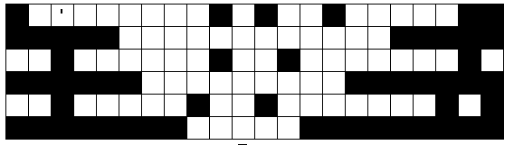
- Fallen phrases

- Italy is a traditional country
- The number of divorces has increased
- The birth rate is low

- Marriages are decreasing
- Many people prefer to live together
- They live together without being married

- Italy is getting older and life expectancy is increasing.
- There are around 7 million single-person families.
- Statistics indicate that civil marriages are taking over religious marriages
- The birth rate is decreasing both among Italians and among immigrants.

Prep: 1. Revise vocab on topic of marriage and family from this week
- Translate into English





