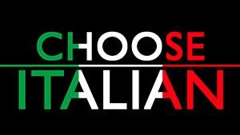
Italian Teachers Day
Saturday 10th March 2018
Francis Holland School, Ivor Place, London, NW1 6XR
9.30 -10.00 Registration
Morning
Italian resources web site (information on teachitalian.co.uk)
Talk: Dr Jennifer Burns, University of Warwick. Routes and roots: approaches to migration in contemporary Italy
Talk: Dr Ruth Glynn, University of Bristol. Perceptions of Naples and the ‘Divario nord/sud’
Round table: Promoting Italian: (Contributions from teachers describing initiatives they have taken, advice etc.) (including presentation on Cinemaitalia)

Lunch

Afternoon

Presentation: Teaching History and producing materials to teach the ‘Dal Fascismo ai giorni nostril” theme (Prof. Giuliana Pieri, Royal Holloway, University of London, Dr David Brown, The Sixth Form College Farnborough and Peter Langdale, North London Collegiate School.)

Talk: Teaching a set text or film (Dr. Daniela La Penna, University of Reading). Those signing up are asked to express a preference

Discussion: The new GCSE - the resources issues

Conclusion (3.30/4.00)
