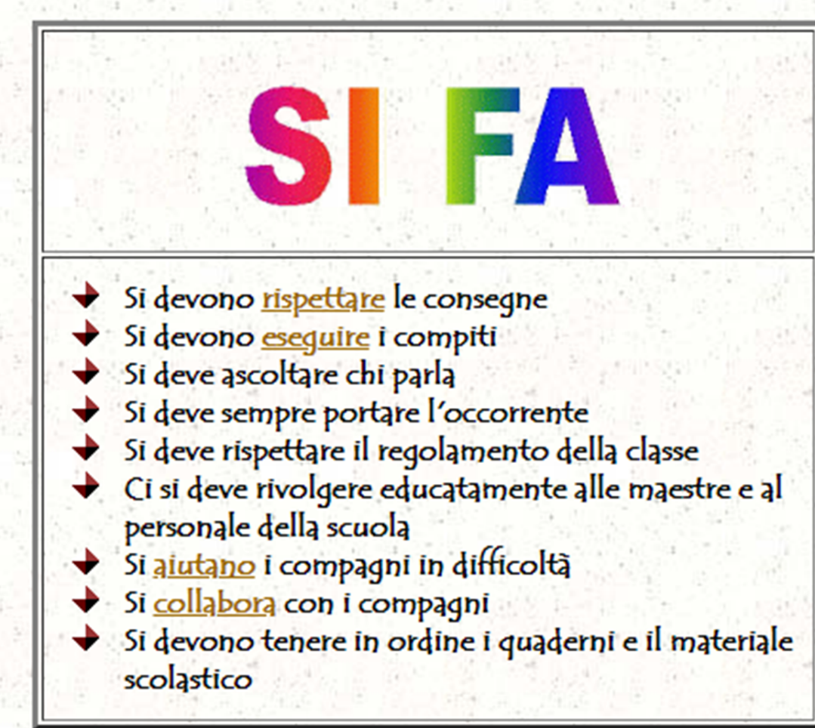
- One should ………………………………………………………….what one is told
- One should ………………………………………………………….homewiork
- One should ……………………………… whoever is ………………………………………………………….
- One should always ………………. what is required
- One should ………………………………………………………….
- One should speak nicely to ………………………………………………………….
- One should …………………………. friends who ………………………………………………………….
- One should ………………………………………………………….with friends
- One should keep exercise books and school material…..…………………………………………………….
- One shouldn’t ………………………………………………when someone is………………………………………………………….
- One shouldn’t ………………………………………………………….
- One shouldn’t ………………………………………………………….
- One shouldn’t …………………………………………………………. one’s friends
- One shouldn’t …………………………………………………………. the food in the dining hall
- One shouldn’t ………………………………… around the common area and ………………………………………………
- One shouldn’t ………………………………………………… materials and school decorations

