Italian Prelim – Film analysis

Marco Tullio Giordana’s I cento passi (2000)

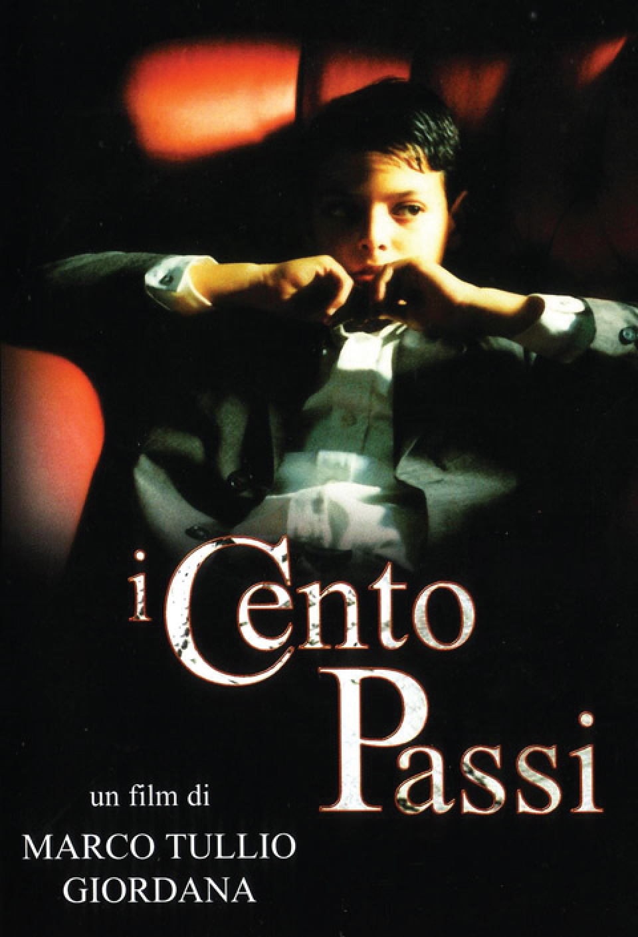

Tutor: guido.bonsaver@pmb.ox.ac.uk

Additional material: downloadable from Weblearn https://weblearn.ox.ac.uk/portal/hierarchy/humdiv/modlang/italian/prelims

Teaching schedule

Michaelmas Term
w 1-2-3-4 Lectures
w 5 Seminars
w 6 Tutorials

Lecture1: Intro and social/historical context
Lecture 2: Mise en scéne
Lecture 3: Editing
Lecture 4: Sound, A thematic reading

Primary material
The film
DVD available at MLF and various college libraries.

Script
Giordana Marco Tullio, Fava Claudio, Zapelli Monica, I cento passi, Milan: Feltrinelli, 2001 [MLF and various colleges]

The film Pressbook in Italian is downloadable from the Weblearn folder.

Language exercise book on I cento passi
Errico, Rocco A, I cento passi di Marco Tullio Giordana, Perugia : Guerra Edizioni, 2007 [MLF and various colleges].

Critical bibliography on I cento passi
- Babini Luana, ‘The Mafia: New Cinematic Perspectives’, in William Hope (ed.), Italian Cinema: New Directions, Peter Lang, 2005, pp.229-250 [MLF, PEM]
- Bondanella Peter, A History of Italian Cinema, New York: Continuum, 2009, pp. 485-486 [MLF]
- Giordana Marco Tullio, ‘Introduzione’, in I cento passi (script), Milan: Feltrinelli, 2001, pp. 5-12. [MLF]
- Marcus Millicent, ‘La scrittura sullo schermo: il martirio antimafia come epitaffio nel cinema contemporaneo’, in Bonsaver G., McLaughlin M. and Pellegrini F (eds.), Sinergie narrative: Cinema e letteratura nell’Italia contemporanea, Firenze: Cesati, 2008, pp. 73-82. [MLF and other college libraries]
- De Stefano George, ‘Marco Tullio Giordana' s The Hundred Steps: The Biopic as Political Cinema’. In: D. Renga, ed., Mafia Movies: a Reader, 1st ed. Toronto: University of Toronto Press, 2011, pp.21-35. Also available online http://members.authorsguild.net/gdestefano/files/I_Cento_Passi_Article_from_Mafia_Movies.pdf
- D’Onofrio Emanuele, ‘Percorsi di identità narrativa nella memoria difficile: La musica in I cento passi e Buongiorno Notte’, The Italianist, 30.2 (2010), pp. 219-244
- O’Leary Alan, ‘Marco Tullio Giordana and the Persistence of impegno’, in Postmodern Impegno: Ethics and Commitment in Contemporary Italian Culture, ed. by Pierpaolo Antonello and Florian Mussgnug (Oxford: Peter Lang, 2009), pp. 213-232
- Paparcone Anna, ‘"Beyond Politics: The Cinema of Marco Tullio Giordana." in Italian Political Cinema. Public Life, Imaginary and Identity in Contemporary Italian Film, edited by Christian Uva and Giancarlo Lombardi, Peter Lang, 2016, pp. 185-198.
- Pugliese Stanislao, ‘I cento passi’, American Historical Review, 6.3 (June 2001), pp. 1109-10 [available online through SOLO]
- Renga Dana, ‘Oedipal Conflicts in Marco Tullio Giordana's The Hundred Steps’, Annali d’italianistica, 2012, pp. 197-212
- Small Pauline, 'Giordana's I cento passi: renegotiating the Mafia codes' in New Cinemas: Journal of Contemporary Film Vol.3 No.1 - 2005, 41-54.
- Vangopulous Katrina, ‘I cento passi’, Cult Print Review, 6 April 2009
http://cutprintreview.com/features/italian-retrospective/italian-retrospective-2-i-cento-passi-the-hundred-steps/
- Vighi Fabio, ‘I cento passi: resuscitating Oedipus with Marco Tullio Giordana’, in Traumatic Encounters in Italian Film: Locating the Cinematic Unconscious, by Fabio Vighi, Intellect Books, Bristol, 2006, ch. 4.3
- Zapelli Monica, ‘I cento passi: come l’abbiamo scritto’, Script, 25 (2000), pp. 19-30 [downloadable on Weblearn]

Historical background

Behan Tom, Defiance: The Story of One Man Who Stood up to the Sicilian Mafia, London: Tauris, 2008 [MLF]
Dickie John, Cosa Nostra : A History of the Sicilian Mafia, London: Hodder&St., 2004
- Puglisi A. and Santino M. (eds.), Felicia Bartolotta Impastato, La mafia in casa mia [interview with the mother of Peppino Impastato], La Luna, Palermo 1986 [MLF]
- Russo Spena Giovanni, Peppino Impastato : anatomia di un depistaggio : la relazione della Commissione parlamentare antimafia, Roma : Riuniti, 2001 [MLF]
- Vitale Salvo, Nel cuore dei coralli : Peppino Impastato : una vita contro la mafia, Rubbettino, 2002 [MLF]
- Vitale, Salvo (2007). ‘La militanza rivoluzionaria di Peppino attraverso i suoi appunti’. In: Umberto Santino and Salvo Vitale, Scritti su Peppino (Online: http:// www.centropeppinoimpastato.it/conoscere/scritti.php3, pp. 1-8)

Bibliography on film studies
Our reference text will be: Bordwell D and Thompson K, Film Art: An Introduction (Boston: Mc Graw Hill, 2004, various editions)
Others:
- Hayward Susan, Cinema Studies: The Key Concepts, London: Routledge, 1996 [MLF]
- Monaco J., How to Read a Film, Oxford U.P., 1981. [MLF]
- Nelmes J (ed), An Introduction to Film Studies (London, Routledge, 1996) [MLF]

