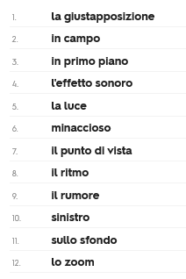
Analysing a scene for Historical Context
affrontare to encounter
la marcia march
commovente poignant
sottolineare to emphasise, highlight

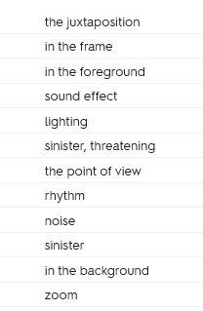

‘Vietato l’ingresso ai ragni e i Visigoti’
https://www.youtube.com/watch?v=2Qoq1X4nWYE
The scene opens with the German soldiers in the foreground. The camera follows them and we hear the rhythm of their march until they exit the frame. Then, there is a zoom on Giosuè underneath the notice ‘Entry forbidden to Jews and Dogs’. The audience sees this from the point of view of Guido, who reads the sign while Giosuè remains unaware.

Osservazioni sul contesto storico
It is important to note that this is the first time that Giosuè encounters discrimination.
___________________________________________________________________________________________________________________________________________________________________
The juxtaposition of innocence and evil is both powerful and poignant.
___________________________________________________________________________________________________________________________________________________________________

Giosuè’s incomprehension emphasises the sense of threat and evil; ‘why can dogs and Jews not enter?’
___________________________________________________________________________________________________________________________________________________________________

Guido tries to protect his son from the reality by inventing* an explanation and joking: ‘Entry forbidden to spiders and Visigoths’.
___________________________________________________________________________________________________________________________________________________________________
*N.B. to say ‘by doing’ something, you can use the gerund form.
ARE verbs -ando parlando
ERE verbs -endo scrivendo

E.g. ‘by speaking, they resolved the problem’

Parlando, hanno risolto il problema

Tocca a voi!
Analizzate le seguenti scene del film, prendendo in considerazione:
- La presenza del contesto storico
- L’uso della musica o del suono
- L’uso delle immagini
- L’uso della comicità/ la tragedia

- Guido portato via dai funzionari
- Festa di compleanno di Giosuè

Essay question:
In che modo la prima parte del film (fino alla partenza per il lager) introduce il contesto storico per la seconda parte?
N.B.
Youtube links to some key scenes you may wish to explore:
Manifesto della razza (a scuola) https://www.youtube.com/watch?v=DoKREKNkJvo
Cavallo ebreo https://www.youtube.com/watch?v=iuk00EHg5SY
Problema di matematica https://www.youtube.com/watch?v=1KIBVCNPsaw
Vietato l’ingresso ai ragni e ai visigoti https://www.youtube.com/watch?v=2Qoq1X4nWYE

